# PROJECT DEVELOPMENT PHASE

**Sprint - 2**

|  |  |
| --- | --- |
| Date | 14 November 2022 |
| Team ID | PNT2022TMID44624 |
| Project Name | Signs with Smart Connectivity for Better Road Safety |
| Maximum Marks | 20 Marks |

**Step – 1:**

Create a Device using IBM IoT platform:

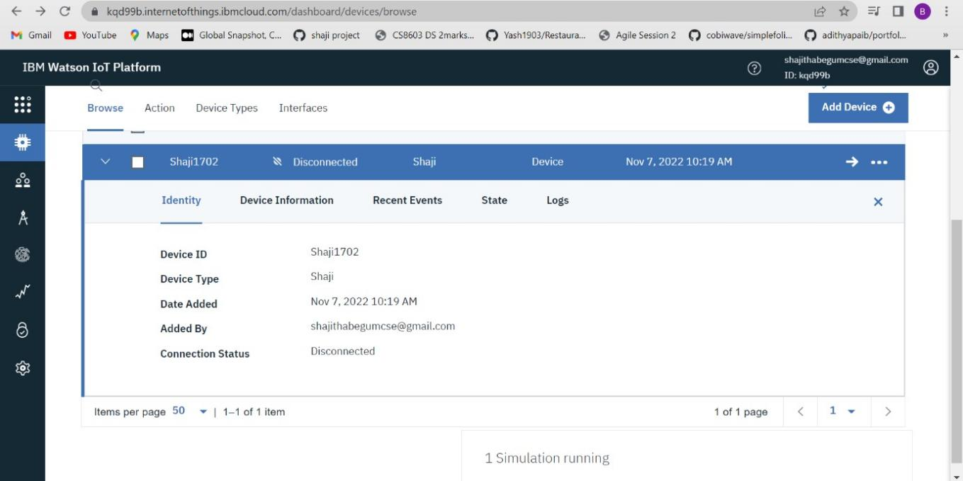

Step – 2

Generating Simulation:

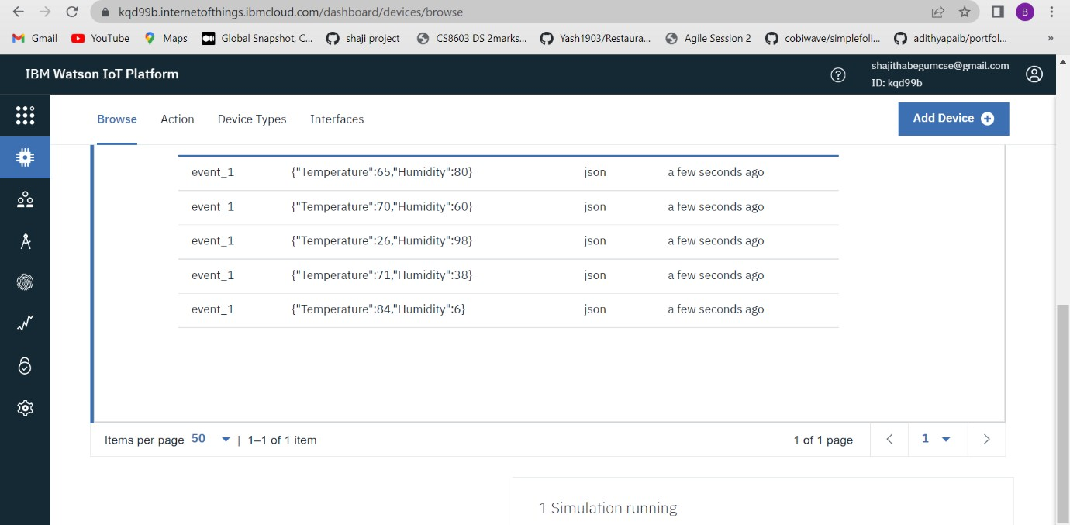

Step – 3:

Creating Node-Red:

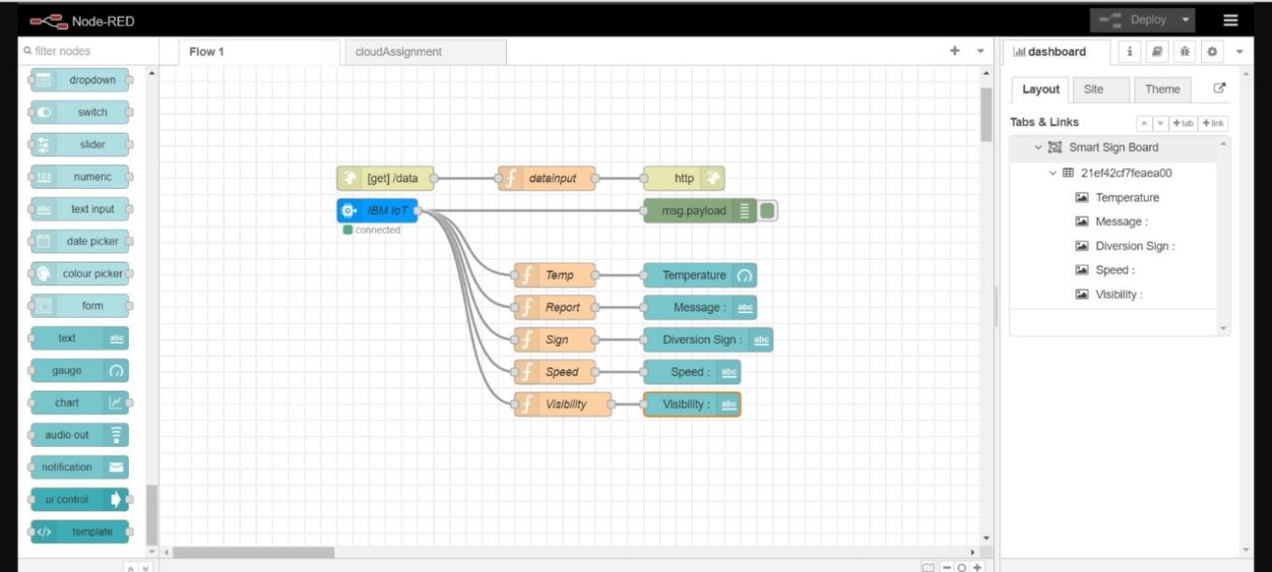

Step – 4:

Altering Link using ui to get the Graphical output :

